**Questions:**

1. Which product categories have the highest total sales in the "Superstore" dataset?

Ans. 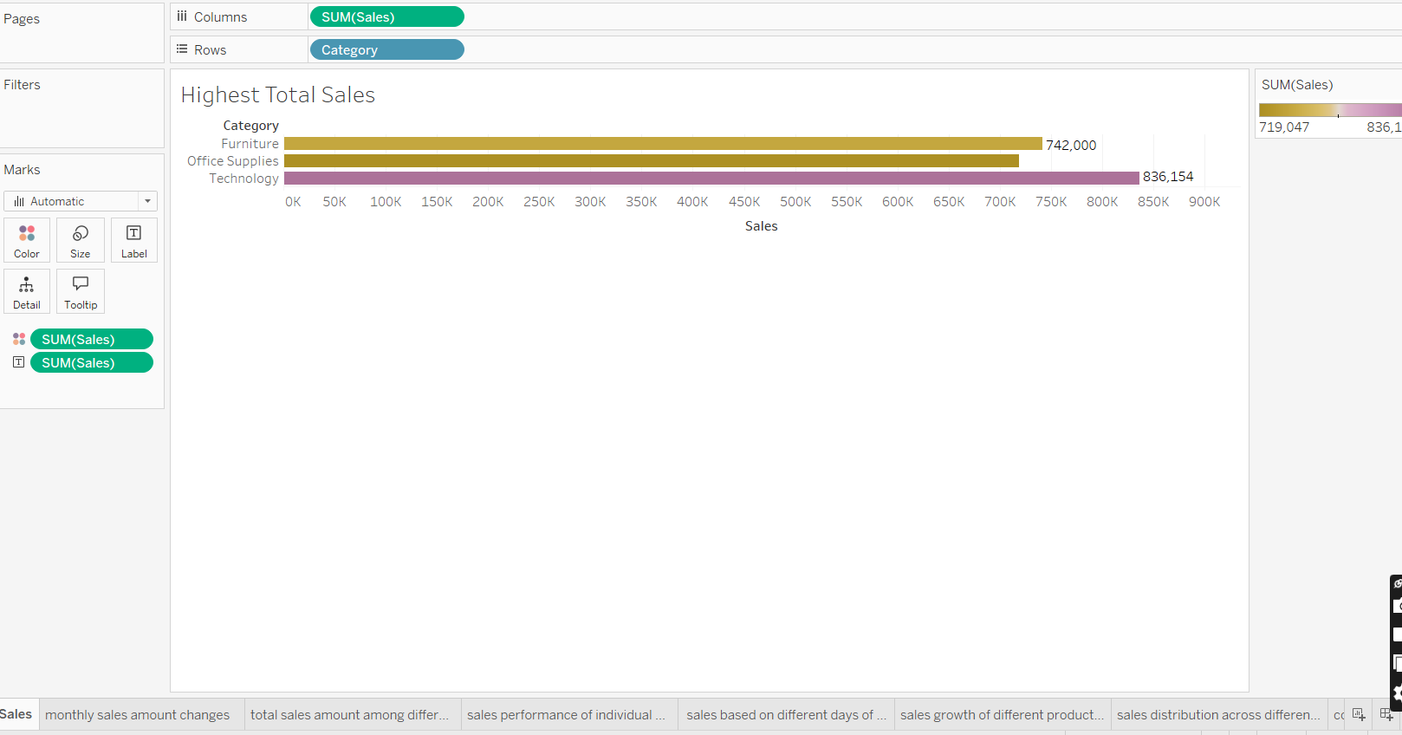

As per above chart, Highest total sales is given by Technology i.e 836,154k ,followed by Furniture and Office Supplies.

Above chart is used because of its simplicity and easy data analysis.

1. How do the monthly sales amounts change over the course of a year?

Ans. 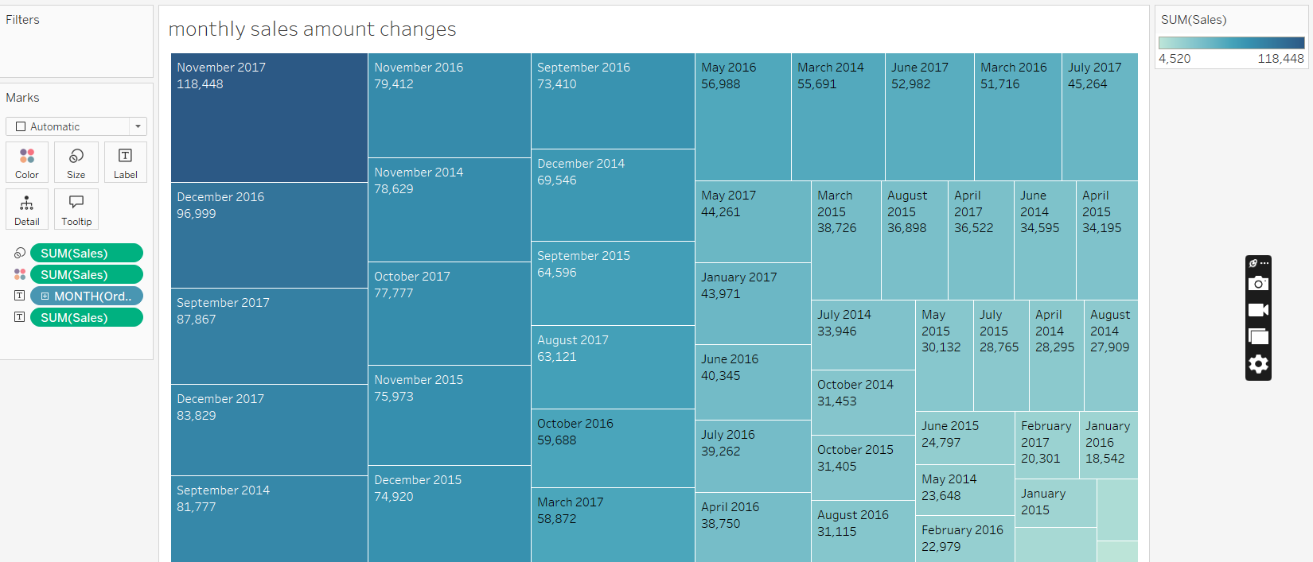

Changes in monthly sales amount over year is shown.This chart was used to access the data in one go without any difficulty. Other charts might complicate if used.

Chart shown consists of data from November 2017,Sales = 118,448k to February 2014 with sales 4,520k (Being the last and smallest block, details can be seen when cursor is moved to the destination).

1. How is the total sales amount distributed among different product categories?

Ans. 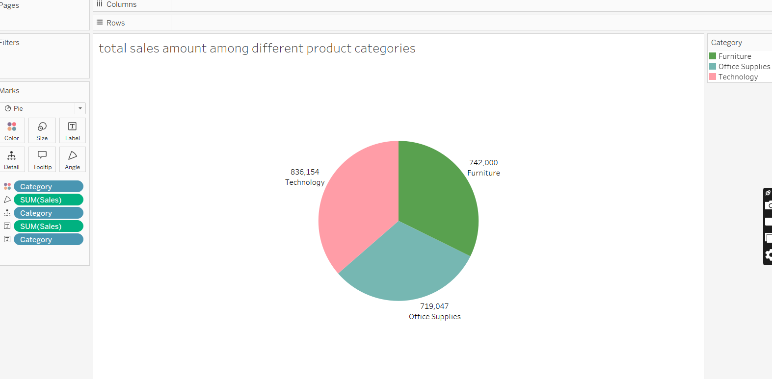

Total sales distribution is shown using Pie chart.These shows clear figures along with category.Major contribution comes from Technology.

Colour coding even simplifies the chart.

1. Can we analyze the sales performance of individual customers over time?

Ans. <https://screenrec.com/share/Q8VWkcKaIP>

Please go through the link once for better clarity as picture wasn’t enough to explain the details.

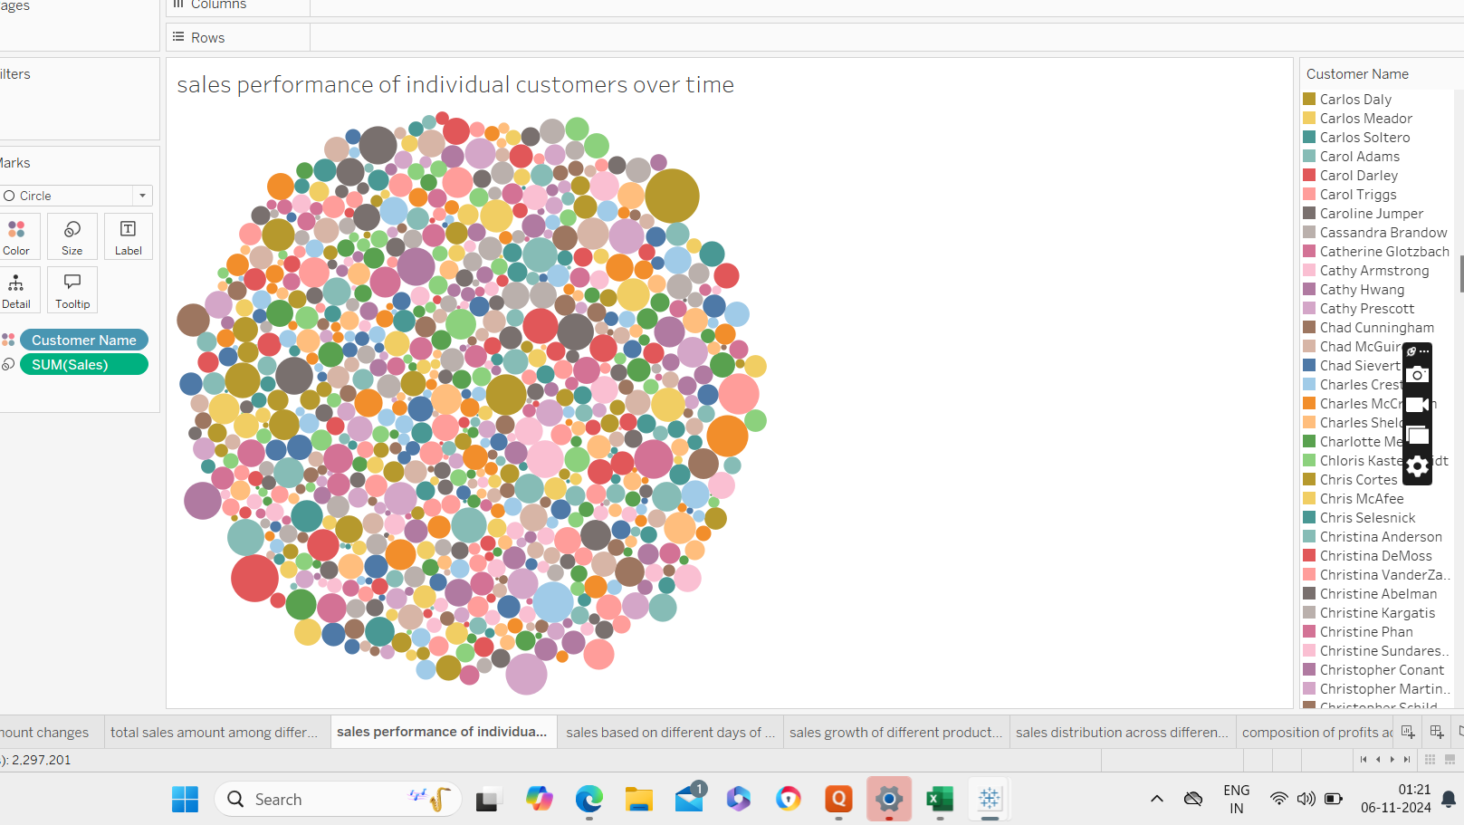

1. How do sales vary based on different days of the week and product categories?

Ans. 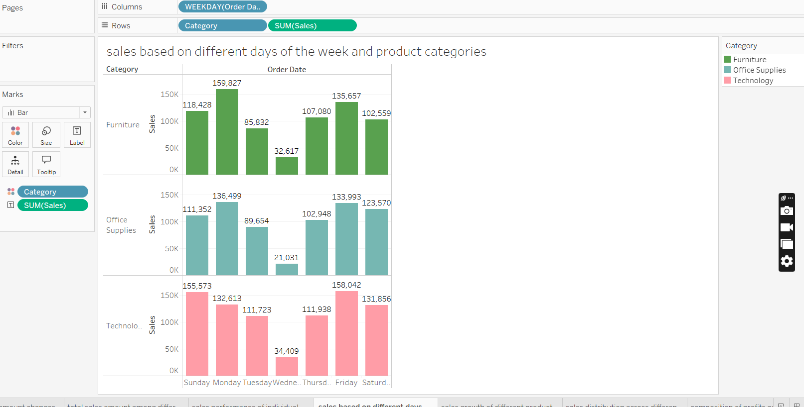

Variation of sales on the basis of different days of the week and product categories is shown.

Basic observation,for all 3 categories,minimum sales can be seen for Wednesday(numbers varies accordingly)

Maximum values changes as per days and categories.

1. Can we visualise the sales growth of different product categories over time?

Ans. 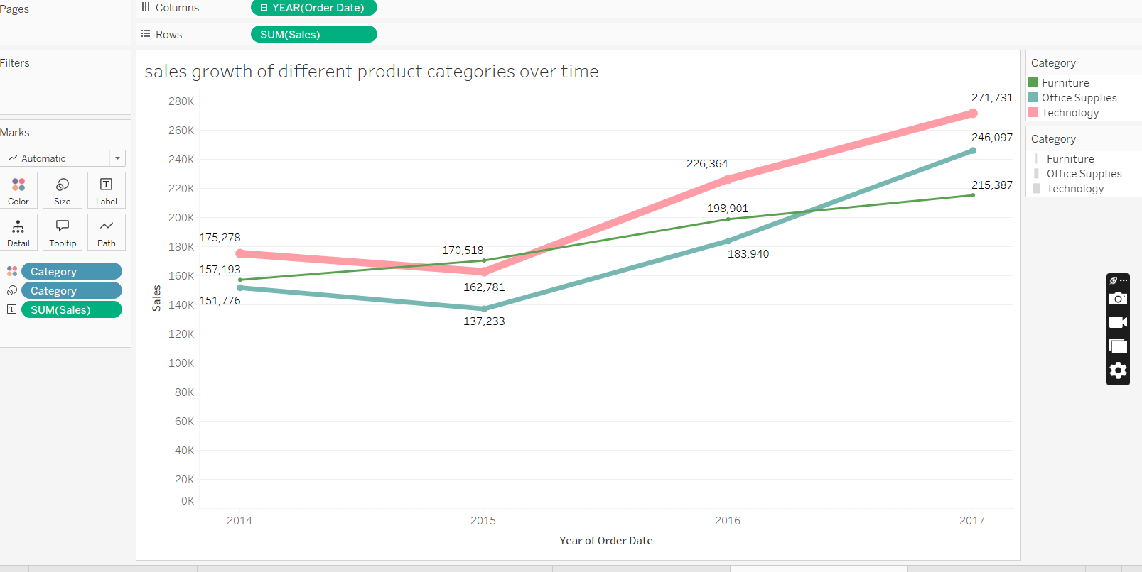

Maximum growth can be seen for Furniture and least being the Office Supplies.Thickness of the lines also specifies the same.

Used the line chart for easy and clear understanding.

2017 was the growth year for all 3 whereas for 2015 sales are higher for Office Supplies but rest 2 categories underperformed the same year.

1. How does the sales distribution vary across different regions in the "Superstore" dataset?

Ans. 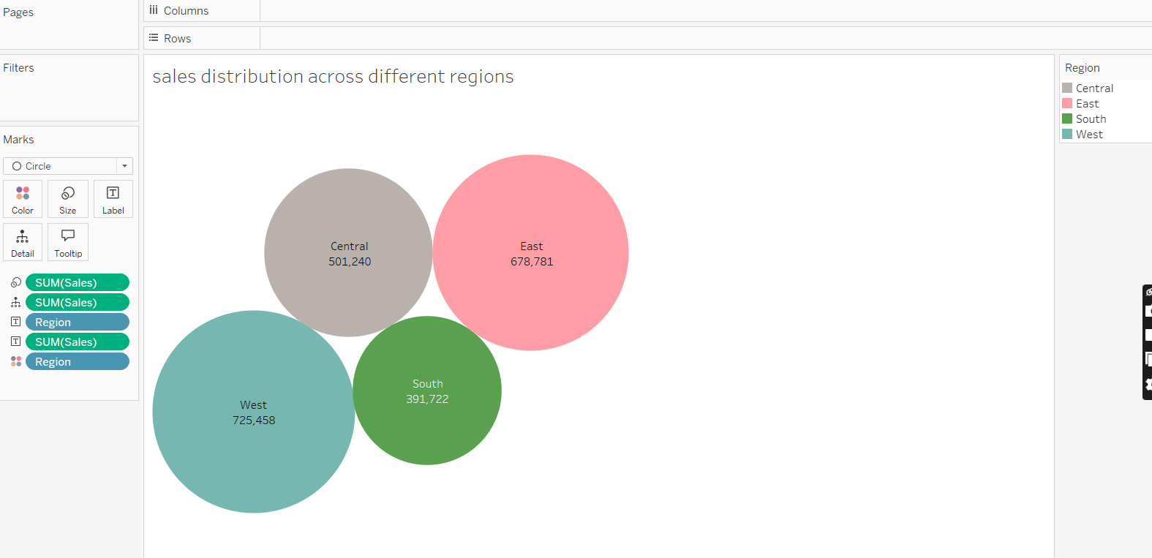

Maximum sales giving region being the West and least being the South.

Bubble chart simplified the data.Bar chart or Area chart or any other chart might complicate the chart.

1. Can we visualise the composition of profits across various subcategories within different customer segments?

Ans. 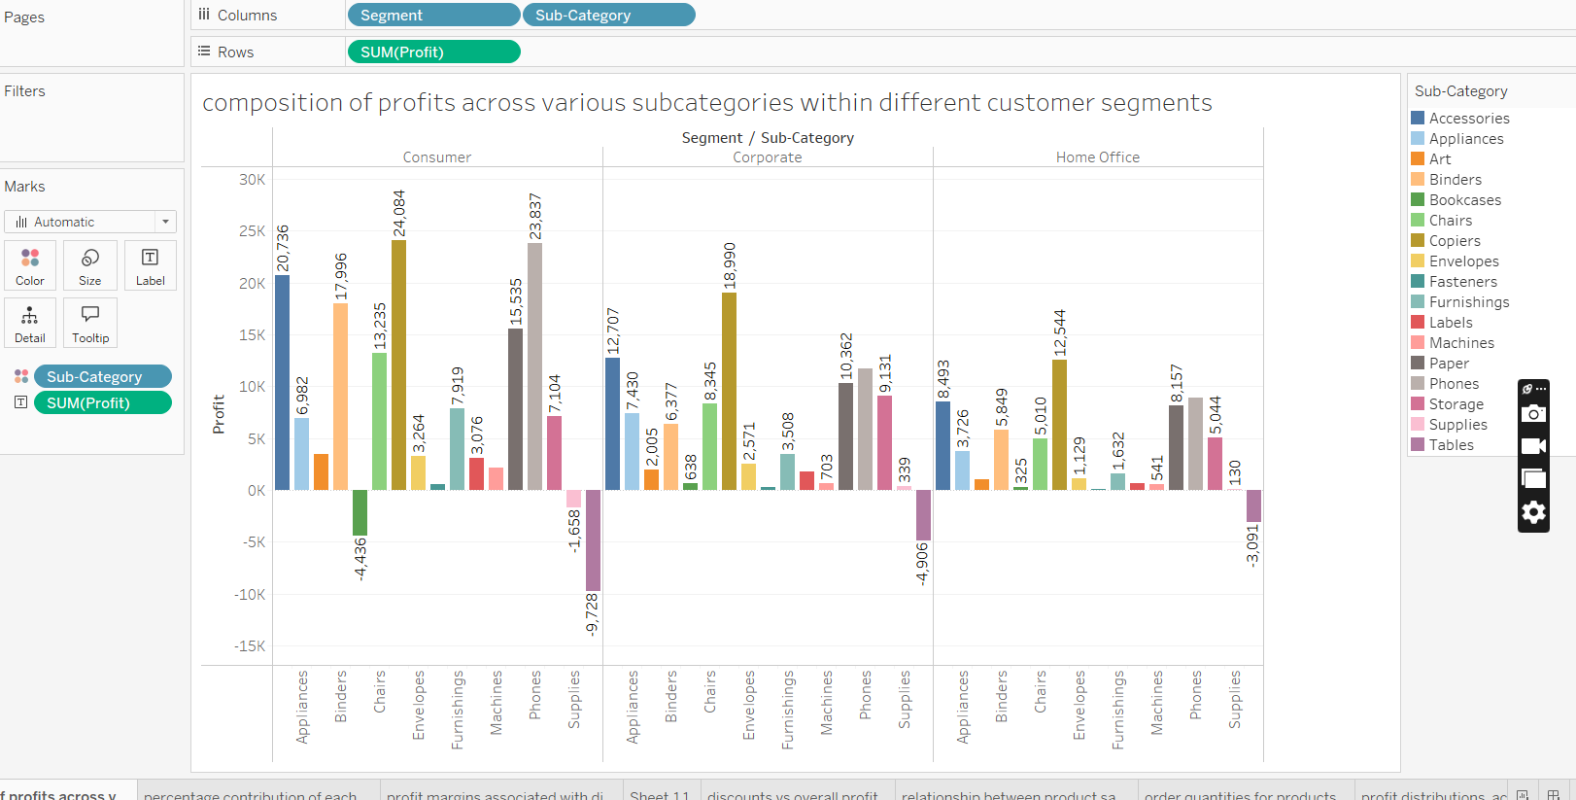

Here,clear analysis of profits for various subcategories,according to customer segment can be seen. Labels with numerical data even adds clarity of figures.

Maximum contribution is from Consumer Segment,from Copiers , 24,084k

Overall least contribution is from Home Office Segment.Values varying as per sub-category.

1. What is the percentage contribution of each region to the overall sales?

Ans. 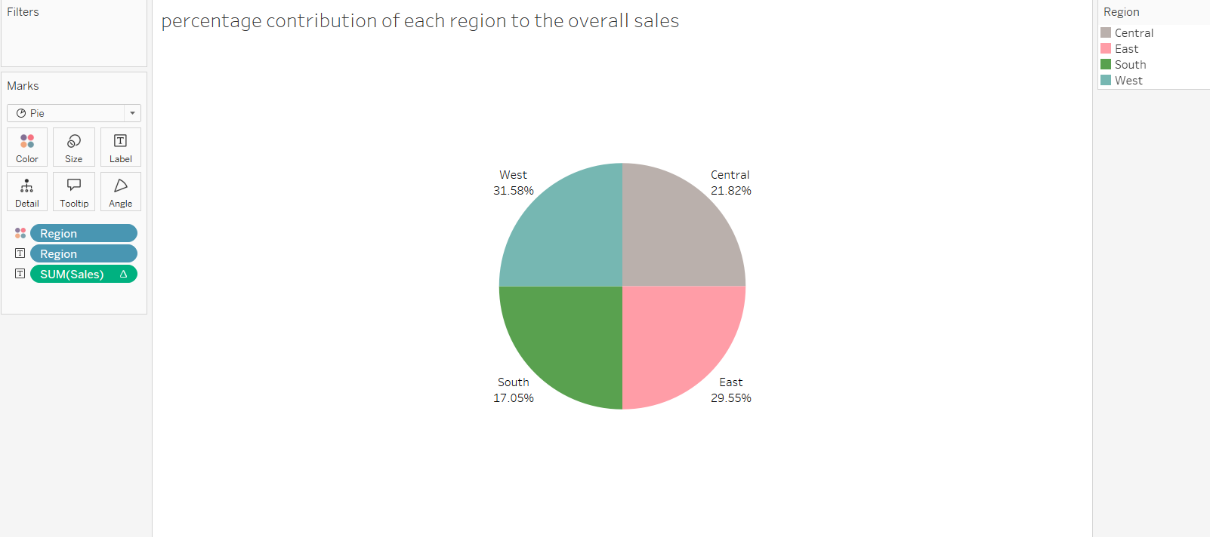

Regionwise contribution can be seen in above Pie chart.

Maximum coming from West while least from the South.

1. Can we visualise the profit margins associated with different shipping modes and customer segments?

Ans.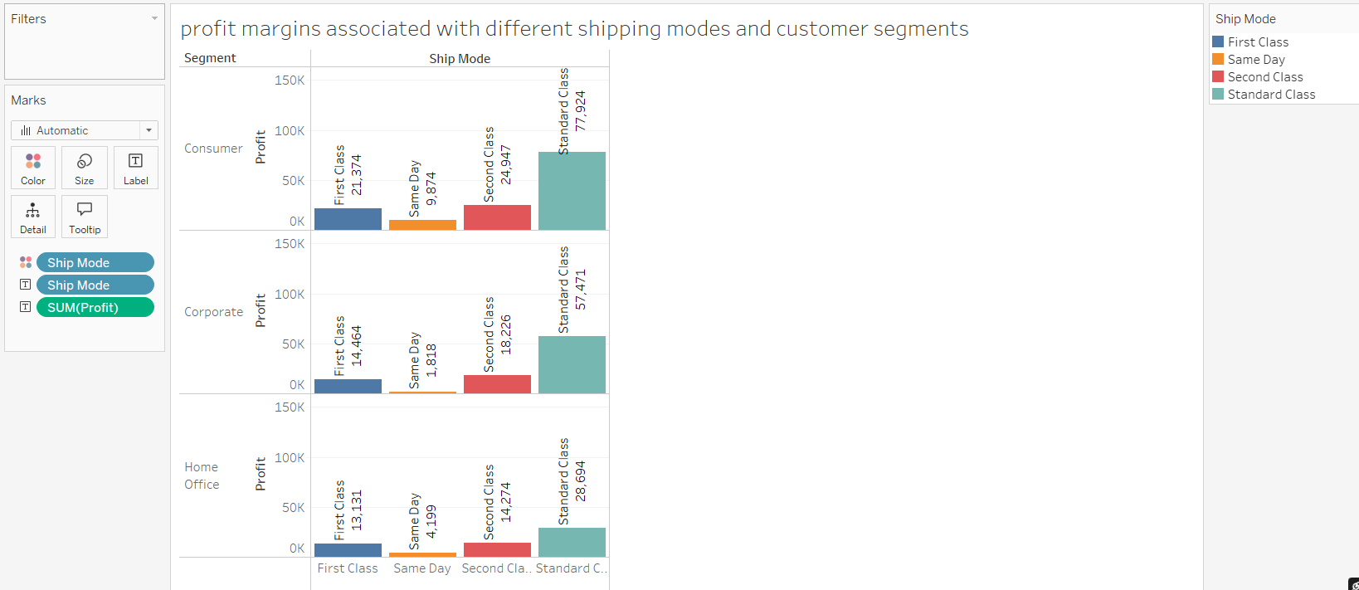

Profit margins associated with different shipping modes and customer segments can be seen.

As per chart,highest profit is from Consumer Segment - Standard Class.

Lowest profit comes from Corporate Segment -Same day.

1. How long does it take to process orders for different product categories?

Ans. 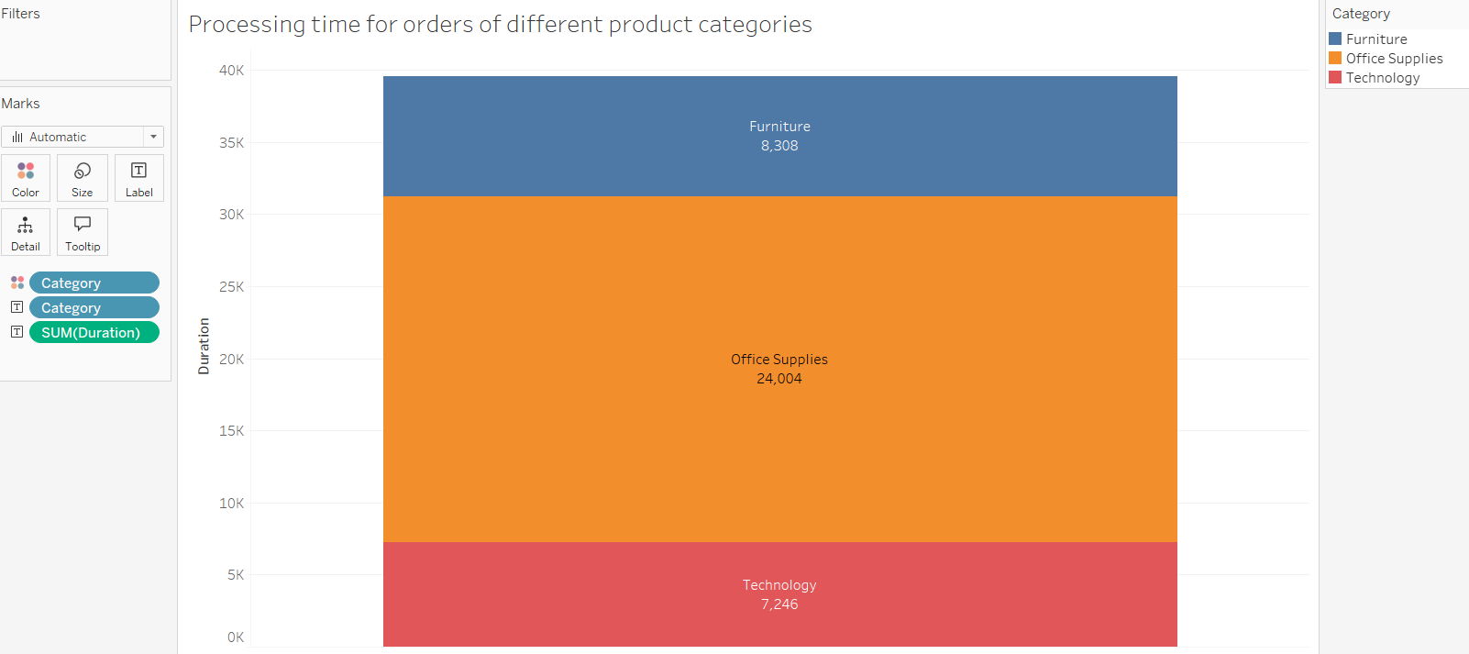

Maximum time being taken by Office Supplies to fulfill the orders while least from Technology.Stacked Bar Chart shows easy comparison of data among following categories.

1. How do discounts affect overall profit?

Ans. 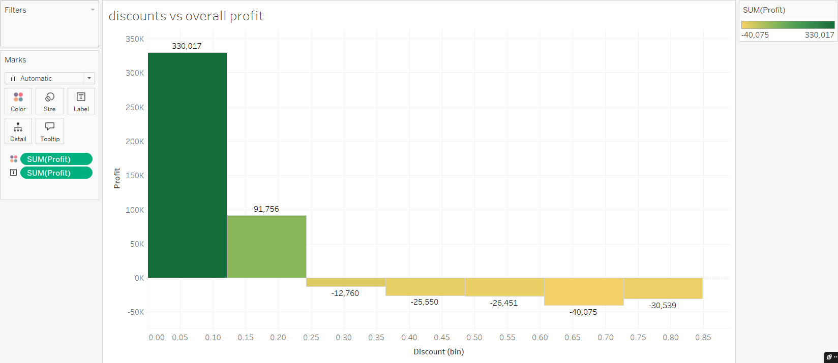

Variation of profit can be seen as discount value changes.For no Discount maximum profit is seen and as discount value increases negative profit value is obtained.

1. Can we visualise the relationship between product sales and profitability for different product categories?

Ans. 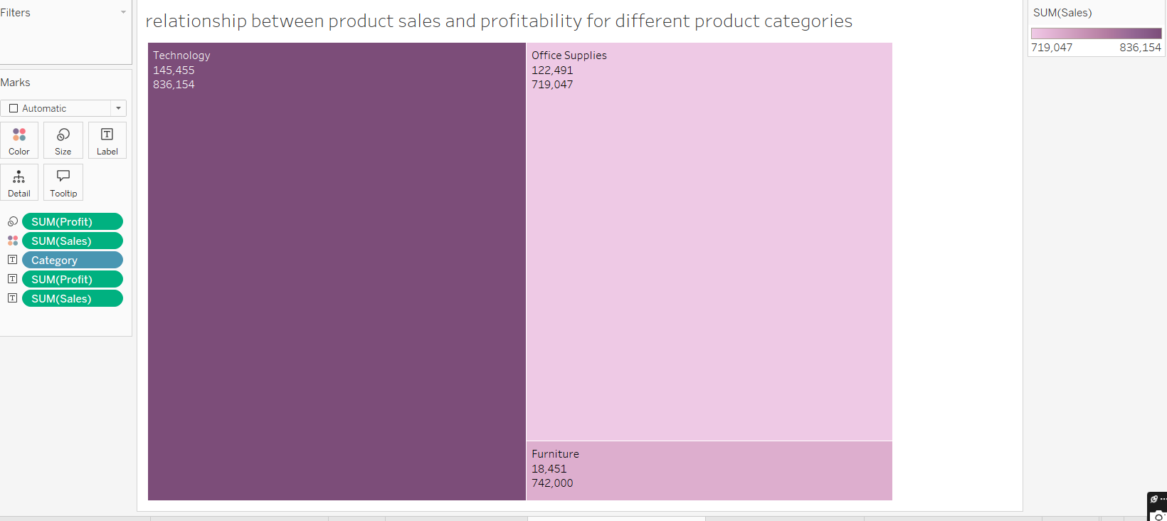

As per product categories,Sum of profit and sales can be seen in numeric form.

For Technology,Sum of Sales = 836154 and profit = 145455 i.e. being the highest and lowest for Furniture.

1. What is the distribution of order quantities for products in the dataset?

Ans. <https://screenrec.com/share/nDMOCpug0y>

Please follow the link for clear view.

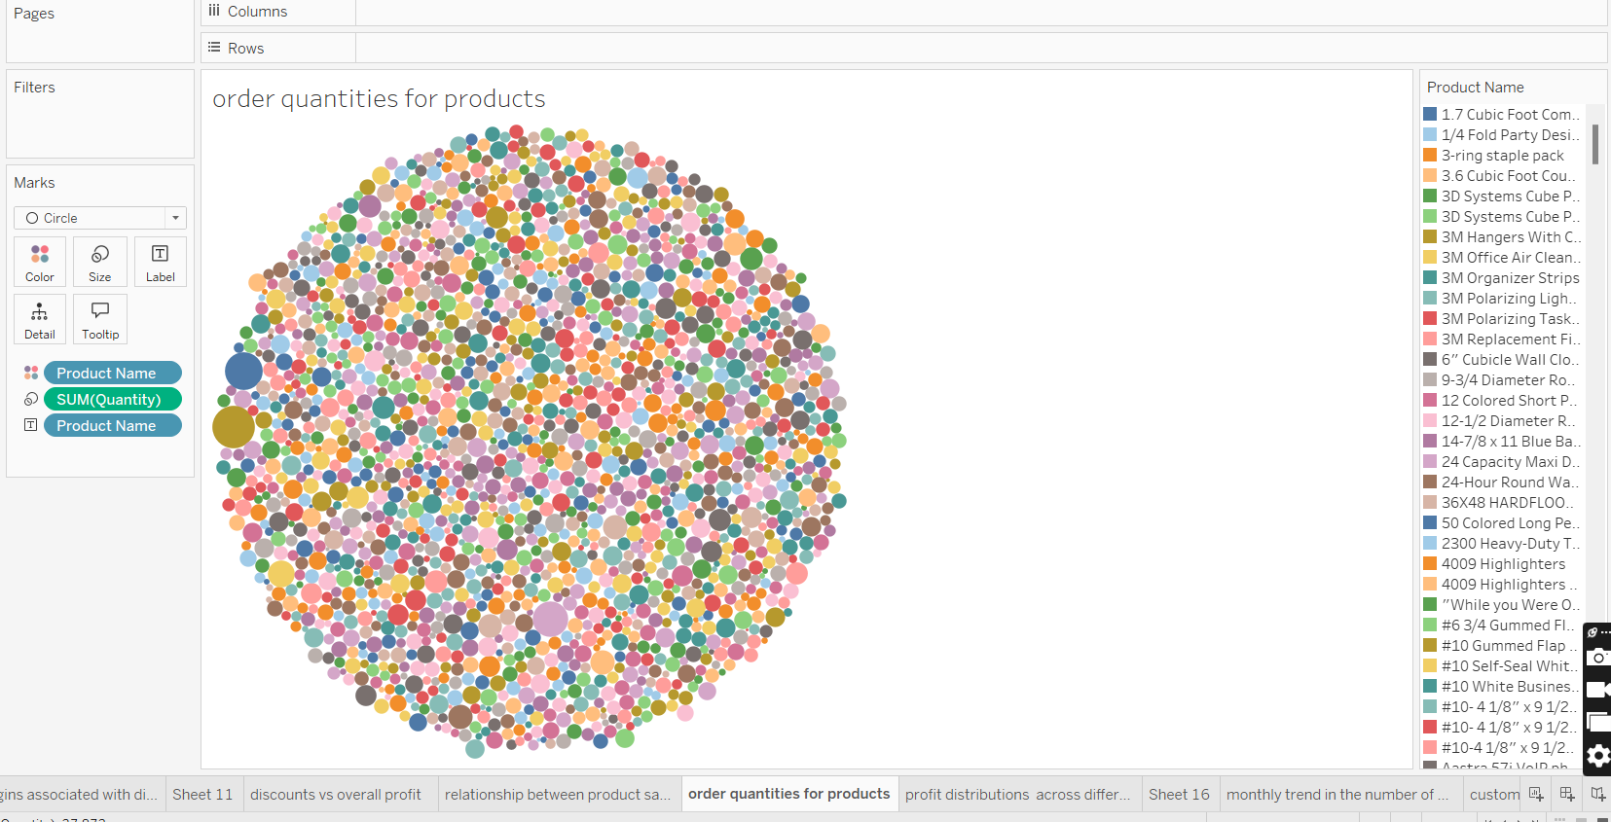

Maximum is from Staples , Sum of Quantity= 215.

1. How do the profit distributions vary across different product categories?

Ans. 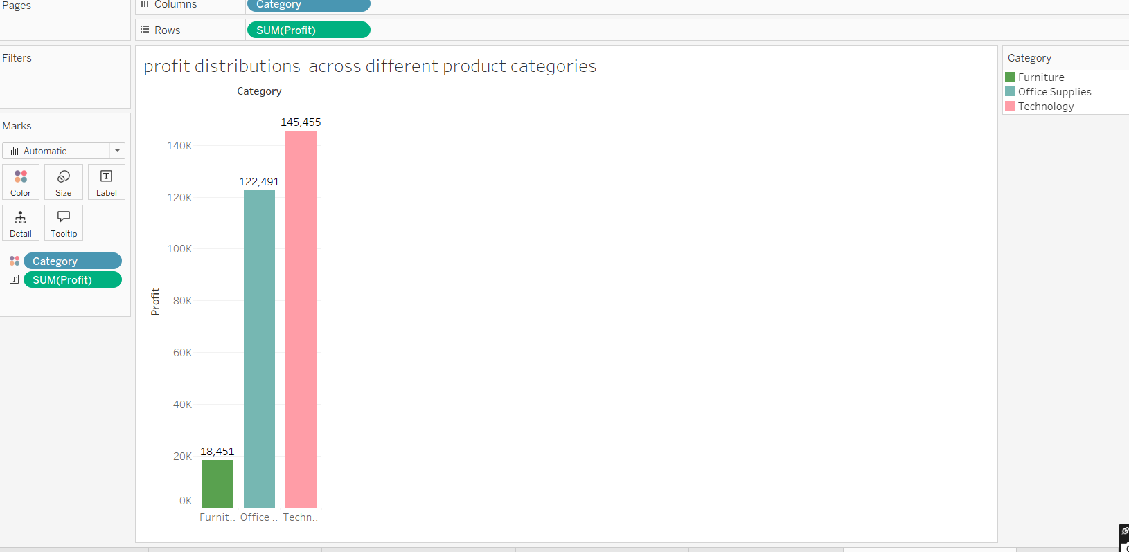

Maximum profit coming from Technology with values 145,455k and least from Furniture with values 18,451k.

Colour coding even simplifies the view.

1. Can we compare the shipping time distributions for different shipping modes?

Ans. 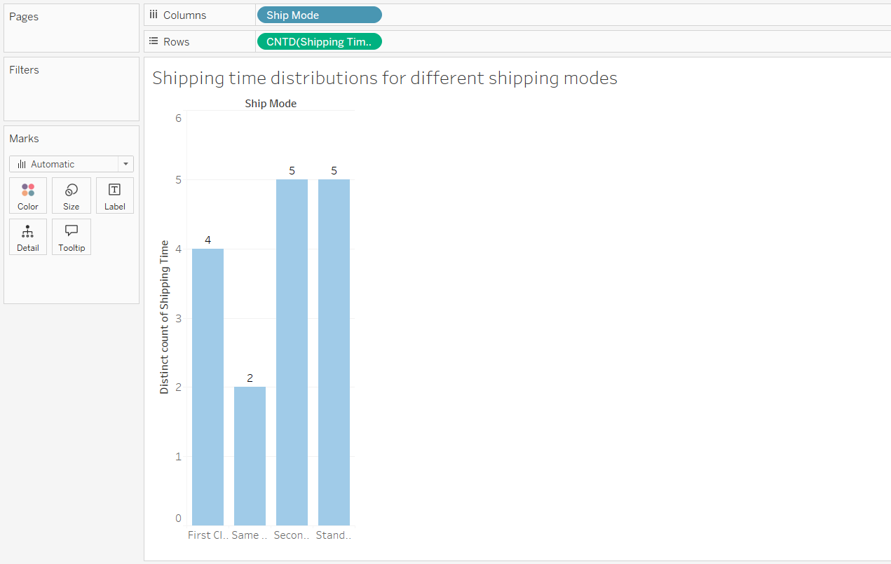

Time distributions for different shipping modes are shown.

Least is for Same Day Ship mode.

Whereas it is same for Second Class and Standard Class ship mode.

1. What is the monthly trend in the number of orders shipped?

Ans. 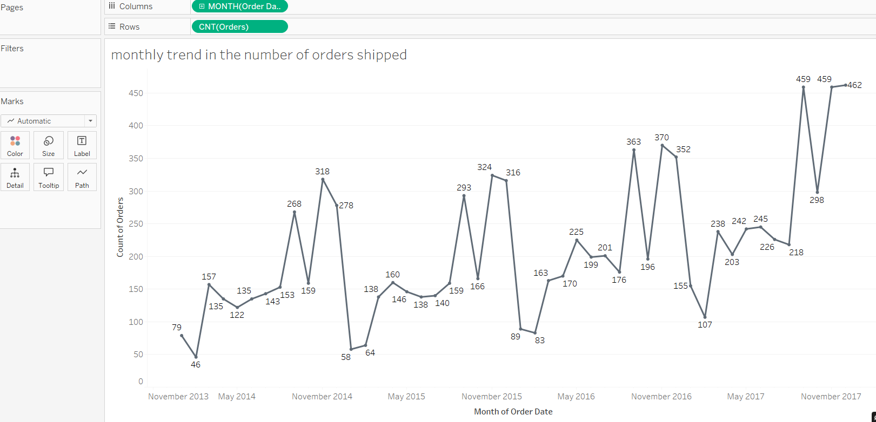

Monthly trend can be seen along with numeric data.There is lot of fluctuations in values.Lowest for February 2014 and highest for December 2017.

By knowing this we can dive to the root cause of less orders and work accordingly.

1. How do different customer segments perform in terms of sales and discount rates?

Ans. 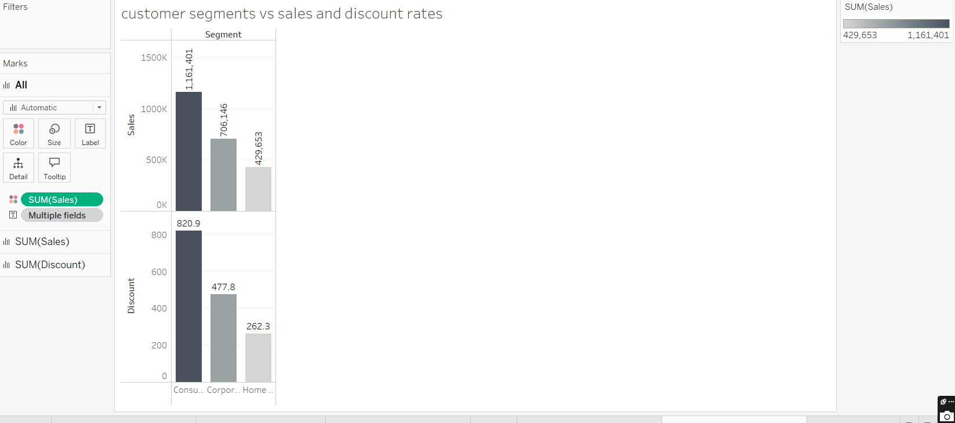

For Sales and Discount ,maximum is from Consumer Segment and least from Home Office for both.Labels shows numeric data for better clarity.

1. What are the sales and profit trends across different product subcategories and regions in the Superstore dataset?

Ans. 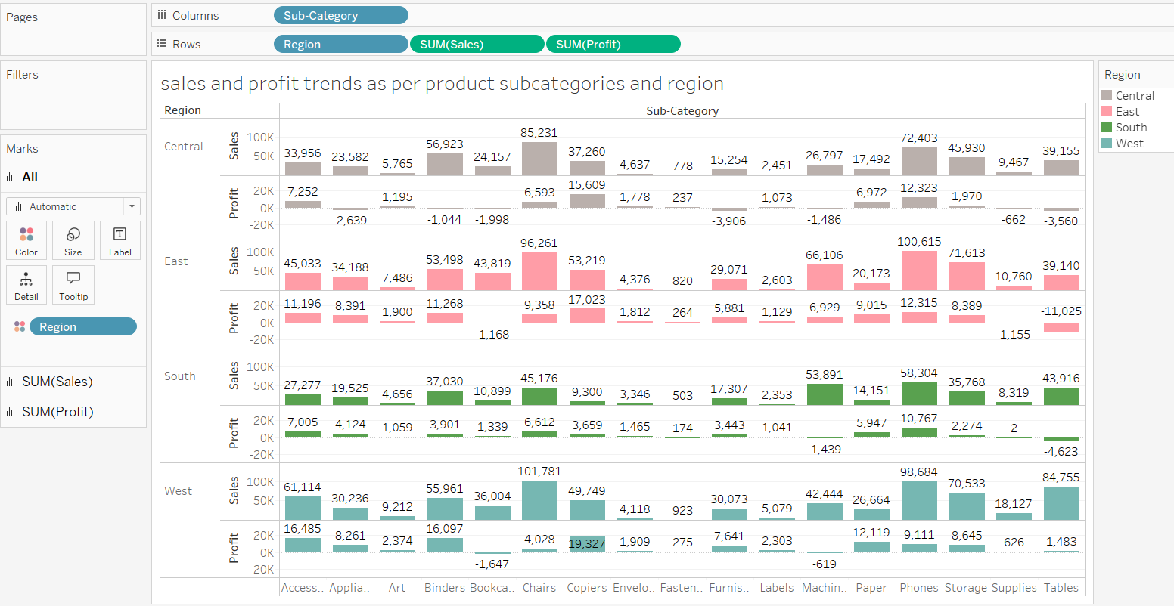

Sales and profit trends across different product subcategories and regions is shown.

For Central Region, Max.Sales 8523k from Chairs and Max.Profit 15,609k from Copiers.

For East Region, Max sales is 100,615k from Phones and Max.Profit 17,023k from Copiers.

For South Region,Max sales is 58,304k from Phones and Max Profit 10,767k from Phones.

For West Region,Max sales is 101,781k from Chairs and Max Profit 19,327k from Copiers.

1. What is the average delivery duration for different regions and ship modes?

Ans.

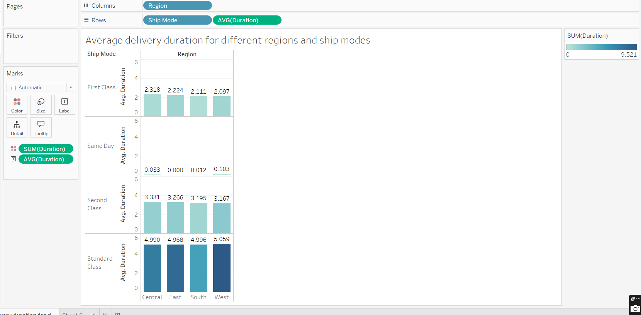

Average delivery duration for different regions and ship modes are shown.

Maximum values are from Standard Class,West being the highest among and Minimum is from Same day,East being the least.

1. How has the average order quantity changed over the years for various product categories?

Ans. 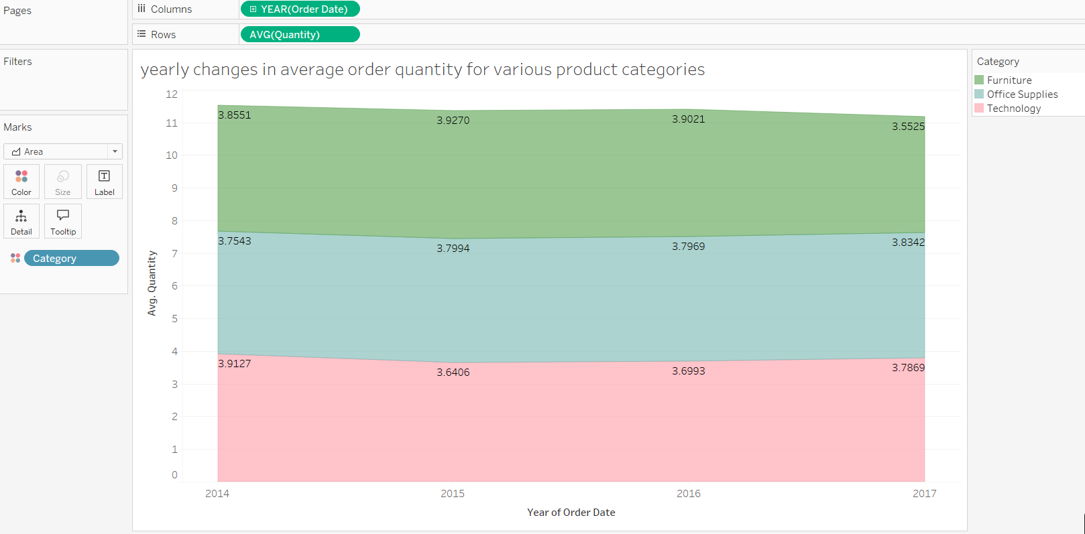

Area Chart is used for clear representation of data.

For Technology, Maximum being for year 2014 i.e.39127, Minimum for year 2015, i.e.36406

For Office Supplies,Maximum being for year 2017 i.e.38342, Minimum for year 2014, i.e. 37543.

For Furniture, Maximum being for year 2015 i.e. 39270 , Minimum for year 2017, i.e.35525.

1. Can we visualise the correlation between discount rates and order quantities for different customer segments?

Ans. 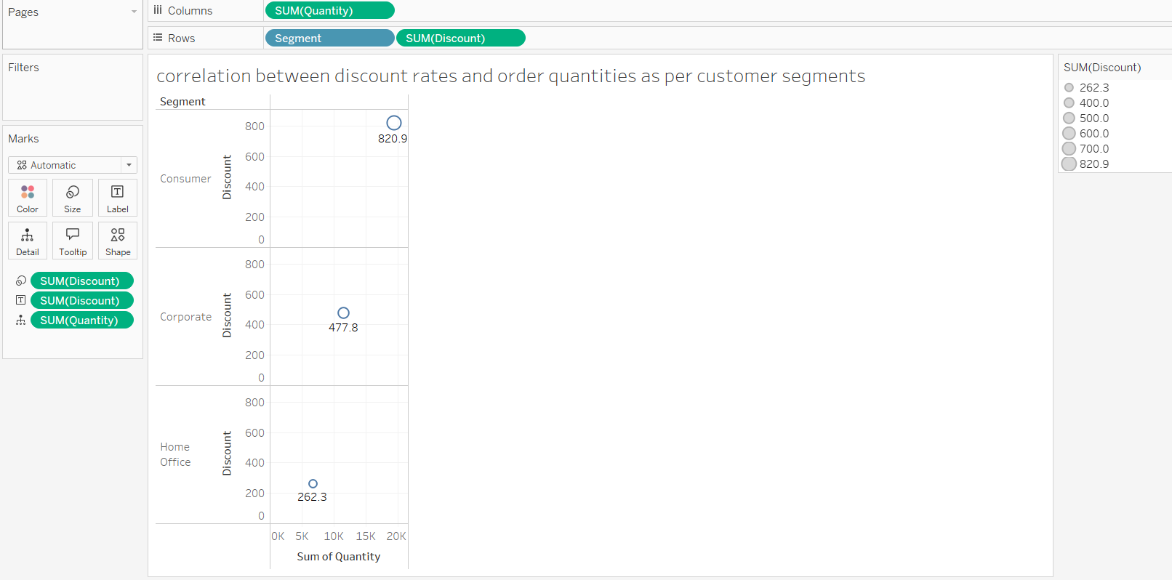

Here relation can be seen with numeric values as per various segments.This chart is used for its simplicity and clarity for data,thus making the analysis even simpler.

1. What is the proportion of orders returned in each region within the Superstore dataset?

Ans.

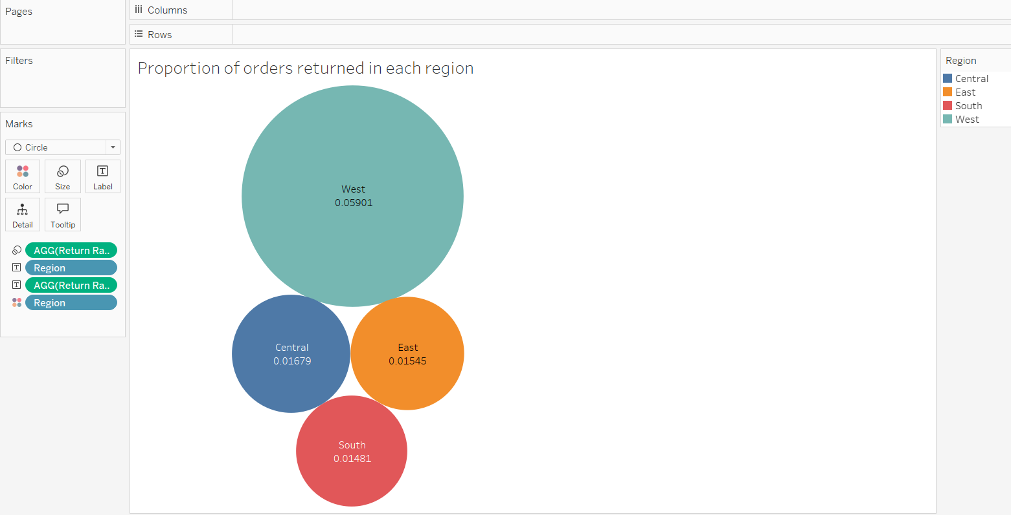

The proportion of orders returned in each region is shown using Bubble Chart.

Least being the South and Highest being the West. Calculated Field named as Return Rate was created to form the chart.

1. Can you compare the profit of different products for different subcategories?

Ans. <https://screenrec.com/share/TtXaxlz7y0>

Please follow the link for clear view.

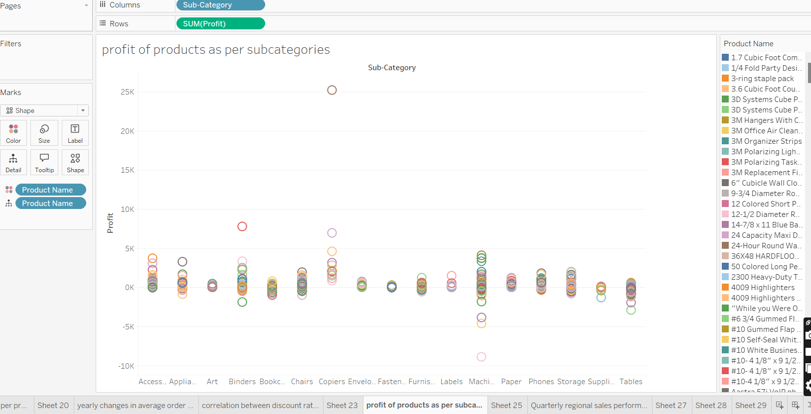

1. Which shipping mode is the most commonly used in the Sample Superstore dataset?

Ans. 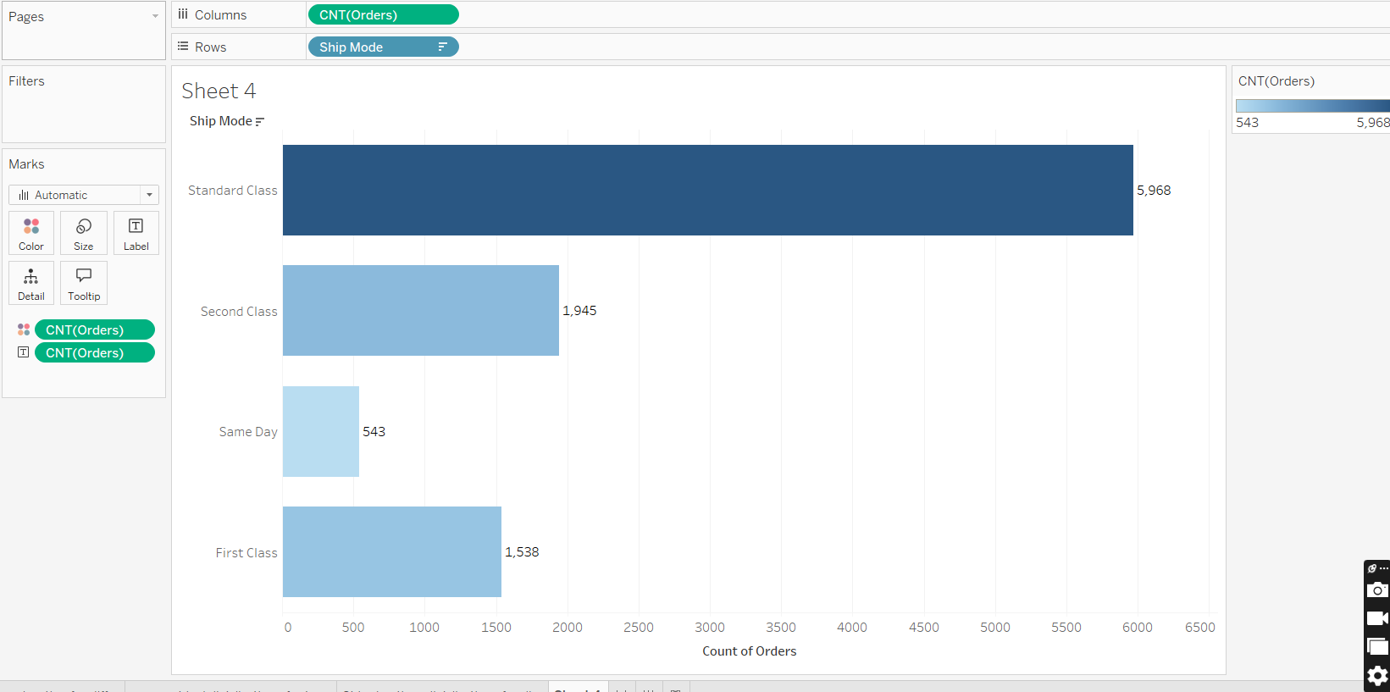

As per chart,we can see that most used shipping mode is the Standard Class for 5968 orders.

Least is for Same day 543 orders.

1. How does the sales performance of different regions evolve throughout the quarters of a year?

Ans. 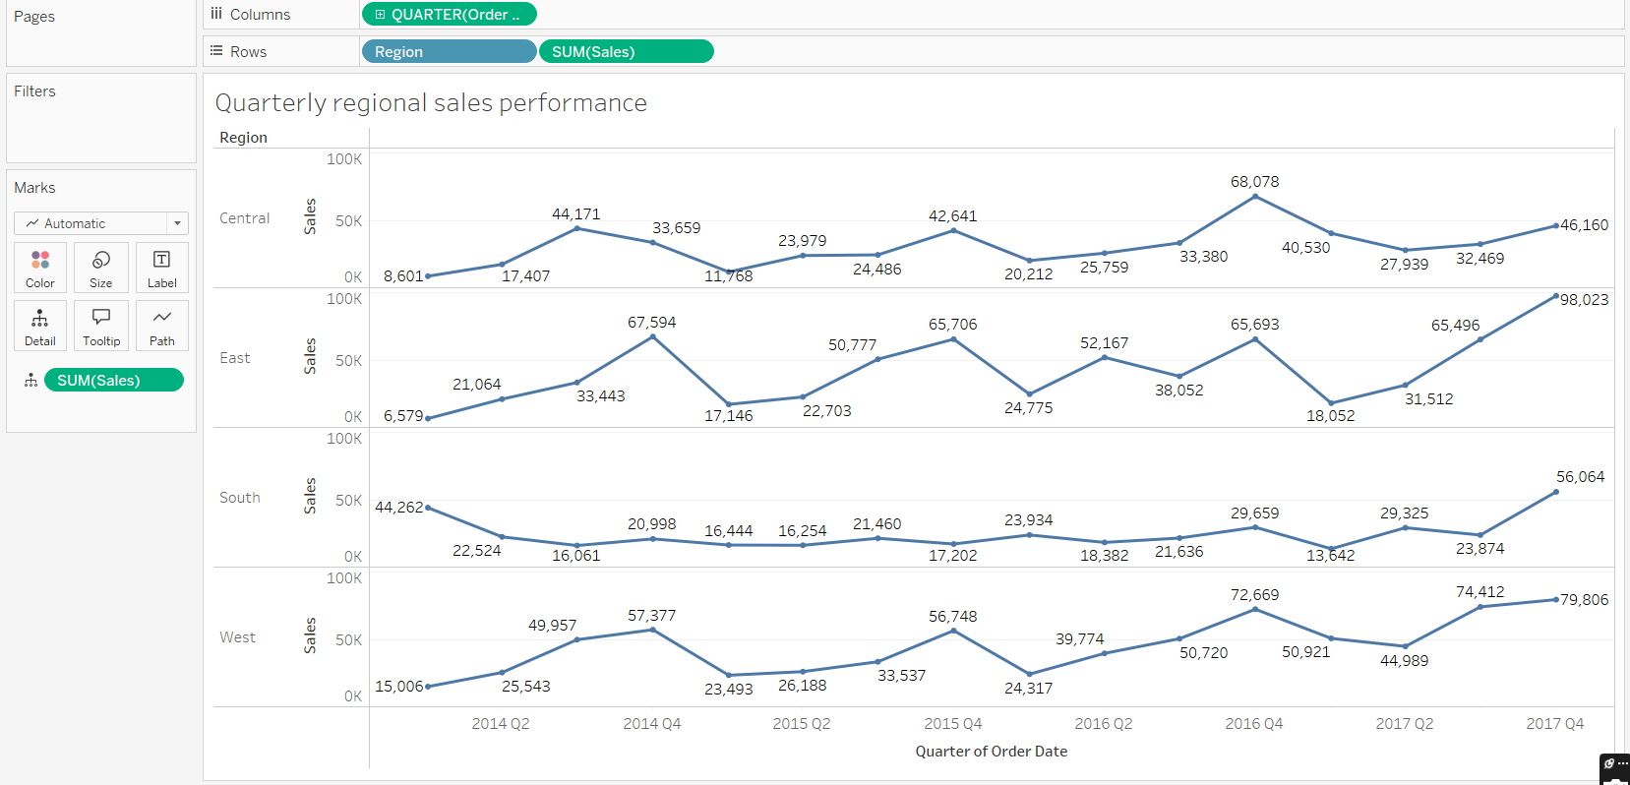

Regionwise distribution is shown using line chart with numeric values for better analysis.

For Central Region, Max is 68,078k(2016 Q4), Min is 8,601k (2014 Q1).

For East Region, Max is 98,023k (2017 Q4) , Min is 6,579k (2014 Q1).

For South Region, Max is 56,064k (2017 Q4) , Min is 13,642k (2017 Q1)

For West Region, Max is 79,806k(2017 Q4) , Min is 15,006k(2014 Q1).

1. What is the distribution of order priorities across different product categories?

Ans. 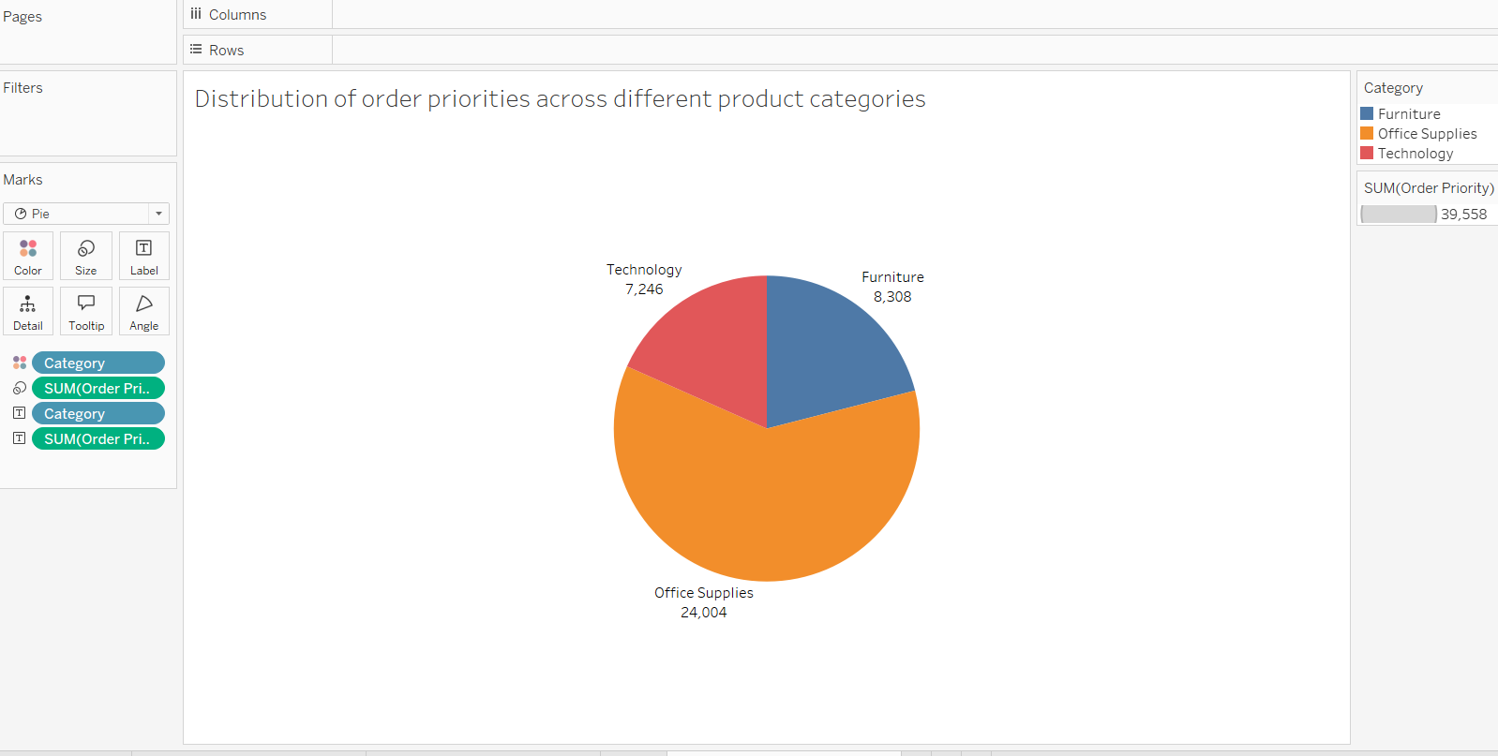

Pie chart shows Distribution of order priorities across different product categories. Maximum is for Office Supplies and Minimum is for Technology.

1. What is the relationship between discounts and sales?

Ans.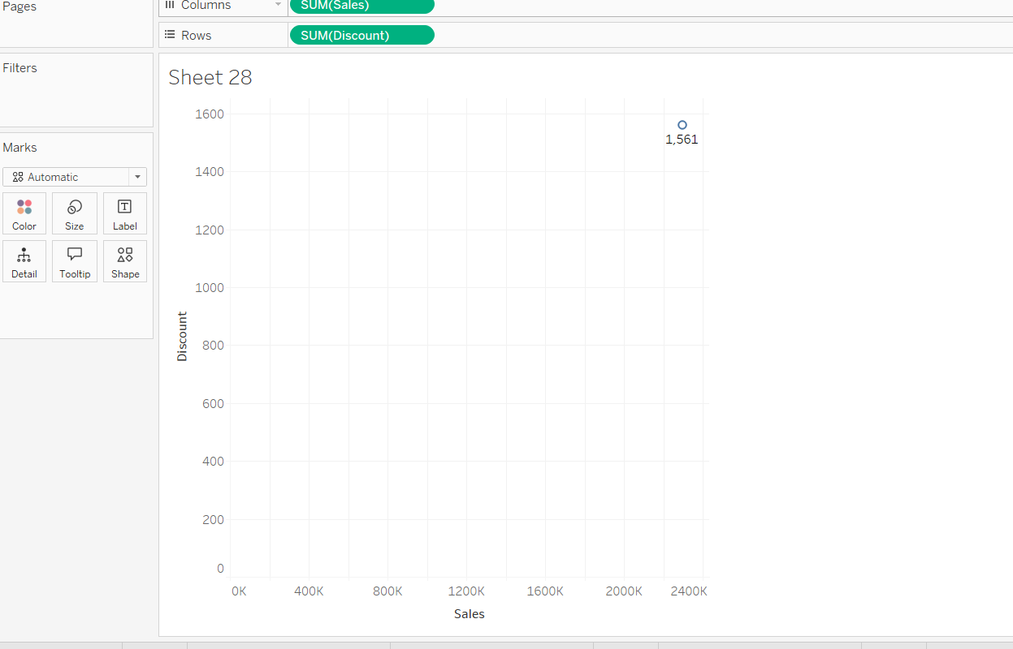

Sum of Sales and Discount is considered to plot the graph.Following graph is obtained on plotting the values.

1. How does the average order value differ between repeat customers and new customers?

Ans. 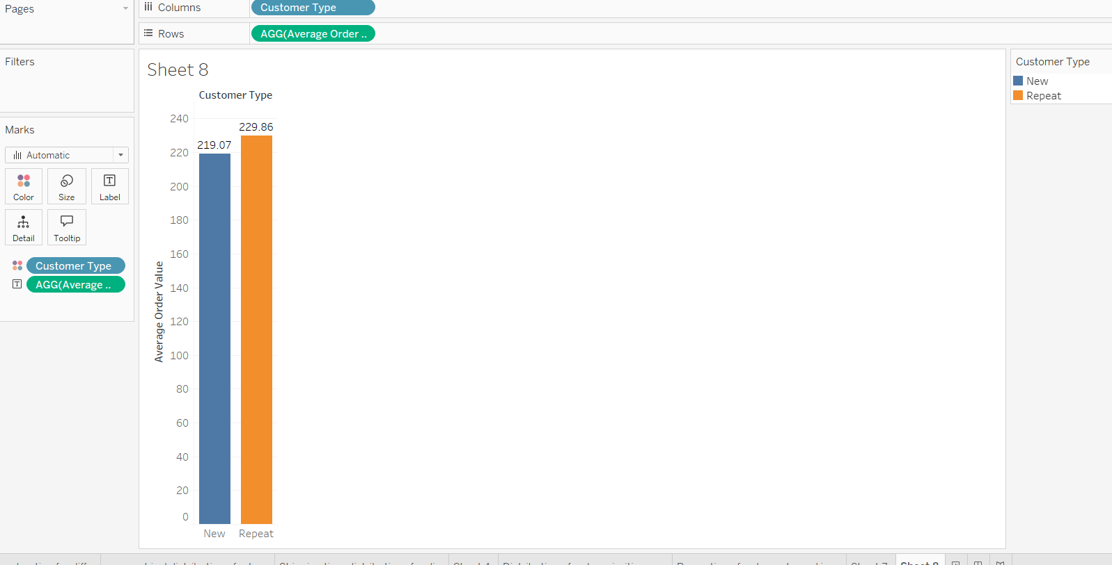

For New Customers, AOV = 219.07

For Repeated Customers , AOV = 229.86

Calculated field was created to have difference between repeated and new customers.Hence graph was obtained.

1. What is the geographical distribution of returns and its impact on overall profitability?

Ans. 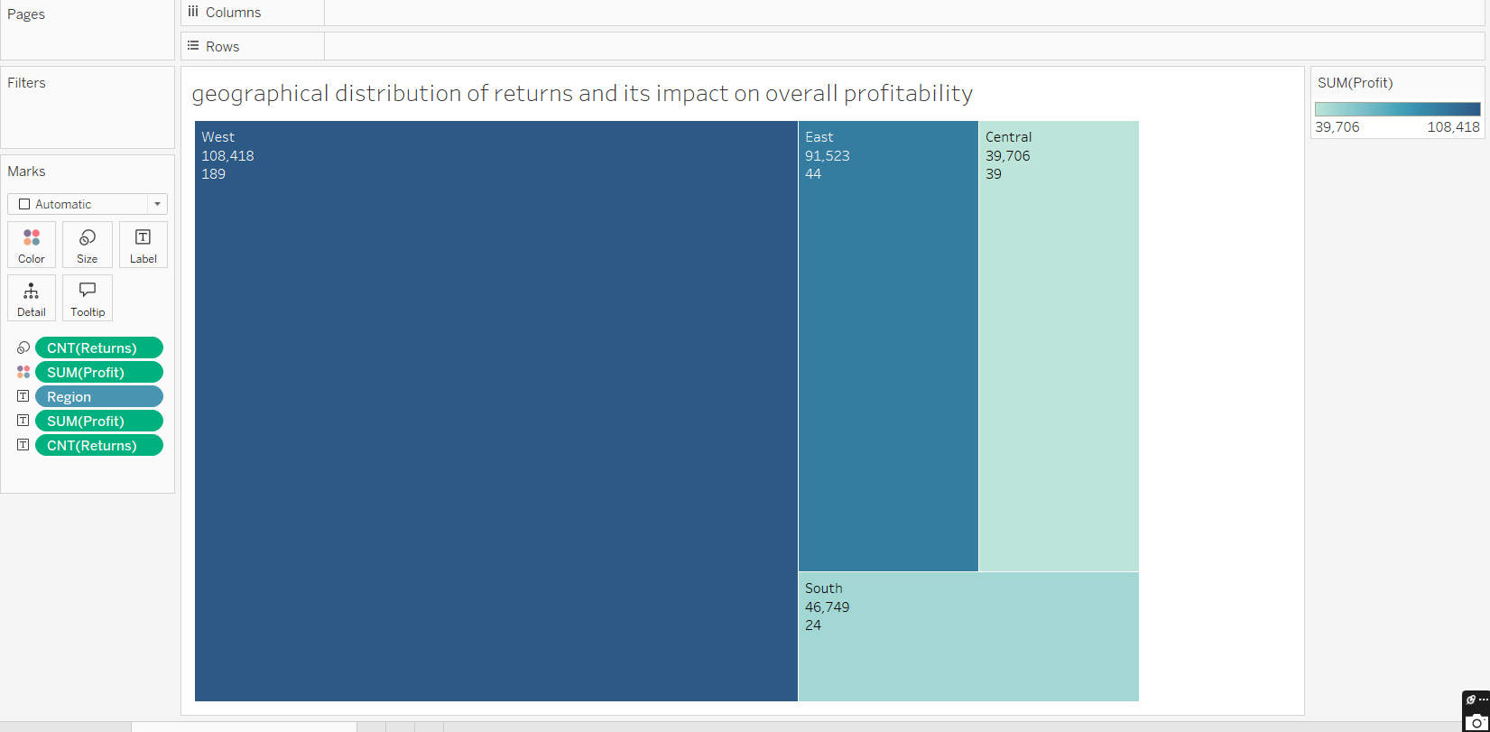

Regionwise returns and profit values are displayed in above chart.Numeric values even makes the analysis easier.Maximum returns are from West whereas least from South followed by the profit numbers.